Citizen Oversight Committee Bio: Dr. Stephany Eley, Education/Member
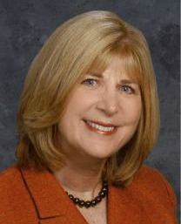
Growing up in Brevard County, Dr. Stephany Eley developed a life-long passion for the Indian River Lagoon (IRL). In her role as Immediate Past President of the Space Coast League of Cities (SCLOC), Dr. Eley was tasked by SCLOC President Stuart Glass to collaborate with Dr. Duane DeFreese to draft, submit, and gain approval of the IRL Regional Compact, “One lagoon, one community, one voice”. Dr. Eley also organized and facilitated the first IRL Summit held last summer at Florida Institute of Technology, her alma mater.
Dr. Eley completed her doctorate degree in 2014 from Liberty University and served for nine years on the West Melbourne City Council. She is Public Policy Coordinator for Christian Care Ministry, a healthcare sharing ministry.
Dr. Eley and her husband, attorney Edmond Eley, have four highly successful children and eight beautiful and talented grandchildren.

