Environmentally Endangered Lands Program
Public Access Plan Public Meeting Minutes

Indian Mound Station Sanctuary and South Lake Conservation Area
February 27, 2020

Attendees
- Jonny Baker, Environmentally Endangered Lands (EEL) Program Staff
- Dani Bowers, Friends of the Enchanted Forest
- Brian Bowers, Friends of the Enchanted Forest
- Laura Clark, EEL Program Staff
- Damien Keene, EEL Program Staff
- Paul Schmalzer, Selection and Management Committee
Protecting and Preserving Biological Diversity
Through Responsible Stewardship of Brevard County’s Natural Resources

Meeting Minutes

Welcome and Public Access Plan Process Overview
Jonny Baker, North Region Land Management Specialist, welcomed the group and thanked everyone for attending the meeting. A copy of his presentation will be added to the Environmentally Endangered Lands (EEL) Program’s web site as a companion document to these minutes.
Environmentally Endangered Lands Program Mission Statement
“Protecting and Preserving biological diversity through responsible stewardship of Brevard County’s Natural Resources.”
EEL Program Vision Statement
“The Environmentally Endangered Lands (EEL) Program acquires, protects and maintains environmentally endangered lands guided by scientific principles for conservation and the best available practices, for resource stewardship and ecosystem management. The EEL Program protects the rich biological diversity of Brevard County for future generations. The EEL Program provides passive recreation and environmental education opportunities to Brevard’s citizens and visitors without detracting from the primary conservation goals of the program. The EEL Program encourages active citizen participation and community involvement.”
EEL Program Public Access Plan Approval Process
The Management Plans for both the Indian Mound Station Sanctuary (IMSS) and South Lake Conservation Area (SCLA) sanctuaries are currently being updated per the 10-year update schedule. Consideration of public access is the first step in the Management Plan approval process.
Before developing a sanctuary’s public access plan, staff conducts a Public Access Site Assessment. From this assessment, the types and extent of passive recreation and environmental education opportunities best suited for each location can be reviewed. Passive recreation is defined as “a recreational type of use, level and combination of uses that do not individually, or collectively degrade the resource values, biological diversity, and aesthetic or environmental qualities of a site.” A conceptual public access plan is presented to the public for review and comment at a publicly advertised meeting. Staff reviews comments received at these meetings and incorporates suggestions when feasible. All comments are incorporated into the proposed public access plan, with explanations provided for suggested activities that cannot be included.
The proposed public access plan is presented to the EEL Program’s Recreation and Education Advisory Committee (REAC) for their review and comment. If the REAC is supportive of the plan, it is incorporated into each sanctuary’s Management Plan which requires approval from the Selection and Management Committee and the Board of County Commissioners during additional publicly advertised meetings. The titles for both the Indian Mound Station Sanctuary and the South Lake Conservation Area are held by the County, so the Board of County Commissioners will have final approval authority for both of these management plans.

Indian Mound Station Sanctuary
The Indian Mound Station Sanctuary (IMSS) is a 145-acre site located east of I-95 in Mims. The northern 60-acres, which were acquired in 2011 can be accessed from a trail head at Holder Park on the sanctuary’s north side or through a gate along Parrish Road, which bisects the site. The southern 85-acres, acquired in 2006 can be accessed at a gate along Parrish Road directly across from the northern section gate. Drive through gates are planned slightly east of the walk-through gates.
The sanctuary is bordered by private property to the east, west, and south. The majority of the habitat consists of oak-saw palmetto scrub, scrubby flatwoods, and floodplain swamp. Many scrub dependent species such as the Gopher tortoise and the Florida Scrub-Jay are present in this sanctuary. A Native American burial mound, an 1800s era tramway, existing trails, and scrub and wetland habitats were identified as resources on site. The adjacent Holder Park, operated by Brevard County Parks and Recreation, includes parking and restrooms. Kiosks at the walk-through northern gate off the Park and at the gate on the southern section, provide a map and information for visitors.
IMSS is a Category 2 site and as such, minimal capital improvements will be implemented. Options include nature trails, parking area, interpretive signs, and kiosks. The site provides public access during daylight hours.
The southern half of this sanctuary, which was acquired first, forms the basis for the original public access plan. Maps showing the original public access plan, existing trail system, and proposed future public access plan were discussed during the meeting.
A map of the proposed public access plan is included with these minutes.
Recap of Changes
The new 1.6-mile trail establishes trail opportunities in the northern half. The existing figure-8 trail in the southern section will be changed to a loop. The existing trail system is being modified to avoid the fire lines, which have been consolidated as the previously existing dirt roads have been allowed to grow in, and to avoid consistently wet areas. The relatively small size of the site, length of planned trail and the sandy and wet soils support hiking and nature observation as permitted activities, but do not support equestrian use or bicycling. Firelines, which require routine disking, are not included as trail locations as hiking recently disked areas is difficult for most people. No changes are proposed for existing kiosk locations, existing parking areas, or existing walkthrough gates. A recent Eagle Scout project improved the parking area within Holder Park providing an easy access to the trailhead.

South Lake Conservation Area
The South Lake Conservation Area (SCLA) is a 207-acre site located west of I-95 in Titusville. The northern portion was acquired in 2000. The Environmentally Endangered Lands (EEL) Program accepted management responsibility for the 52 acres in the southern section a few years ago. SCLA is directly adjacent to Salt Lake Wildlife Management Area, which is managed by the Florida Fish and Wildlife Conservation Commission, to the south and is located in the vicinity of a number of other conservation properties that offer similar recreational opportunities. The sanctuary can be accessed from a trailhead on Lancaster Lane. The site is bordered by private property to the north, west, and east. The majority of the habitat consists of oak-saw palmetto scrub, scrubby flatwoods, and depression marsh. The sanctuary is home to many listed plant and animal species such as the Gopher tortoise, Florida Scrub-Jay, Curtiss’ milkweed, and large flower false rosemary. SCLA is the location of the first Florida Scrub-Jay translocations in Brevard County.
This is a Category 2 site, and as such, minimal capital improvements will be established. The relatively small size of the site and planned trail, and the sandy and wet soils support hiking and nature observation, but do not support bicycling or equestrian use. The shoreline of South Lake is not conducive for fishing or paddling activities. There are several walk-through gates from the neighborhoods. EEL Program parking area is off Lancaster Road.
Maps showing the original public access plan, existing trail system, and proposed future public access plan were discussed during the meeting.
A map of the proposed public access plan is included with these minutes.
Recap of Changes
A portion of the existing trail on the lower east side of the northern section is being removed as trail conditions are no longer favorable due to increased wet areas. An additional trail of 0.9 miles (shown as a blue dotted line) is proposed to connect the 52-acre southern parcel to the northern portion of SLCA and an existing trail system on the Salt Lake Wildlife Management Area. A walkthrough gate will be installed to connect SCLA to the Salt Lake Wildlife Management Area south of Dairy Road. No changes are proposed for existing kiosk locations, existing parking areas, or existing walkthrough gates. Firelines are not indicated as hiking trails at either of these sanctuaries, partly due to difficulty in hiking them, and also because some are located next to private property. No trails are planned for the Core Conservation Area.

Public Comment
It was noted that the Indian Mound Station Sanctuary, in addition to Fox Lake and Scottsmoor Flatwoods Sanctuaries are adjacent to Parks which makes it possible for home school trips to visit these three locations in the North Region, in addition to a few others in other regions.
The importance of including historical information in presentations and plan updates was noted.
A suggestion was received to revise the wording on the top of the hand-out maps to be more clear and to include all three maps as handouts.

Adjourned
The meeting was adjourned at 7:08 PM.

Indian Mound Station Sanctuary Proposed Future Public Access Plan Map
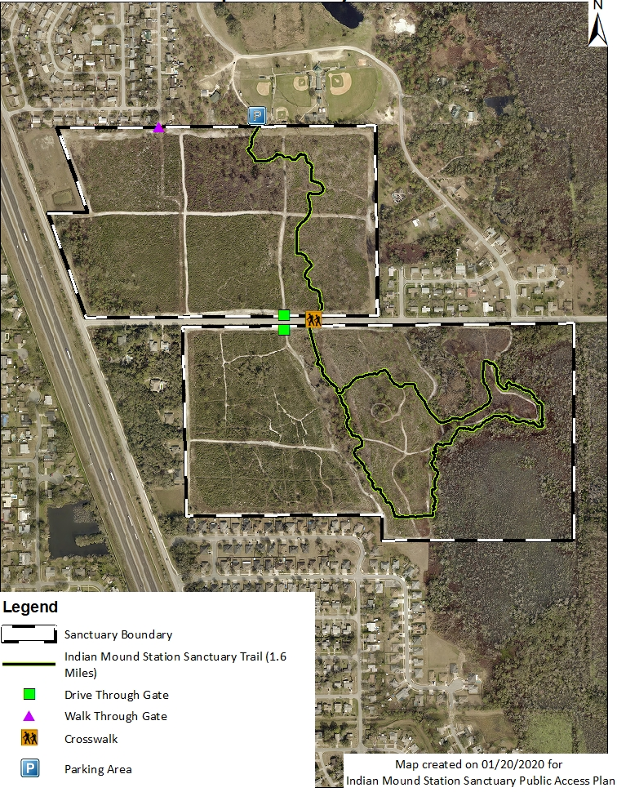

South Lake Conservation Area Proposed Future Public Access Plan Map
