Citizen Oversight Committee Bio: Courtney Barker, Finance/Member
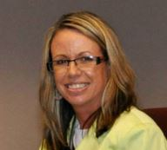
Courtney Barker is currently the City Manager for the City of Satellite Beach. She grew up in Satellite Beach and graduated from Satellite High School (1991). Courtney has a Master of Science in Urban and Regional Planning, Florida State University, and a Bachelor of Arts in Anthropology, University of Florida, 1996. Courtney has worked as an urban planner for most of her career, with positions on with the State of Florida, local government, and the private sector, before becoming a City Manager in 2013. Courtney lives in Satellite Beach with her husband, Sam Barker, and her three children.

