# Citizen Oversight Committee Bio: David Lane, Tourism/Member

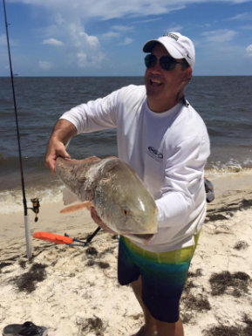

David is the CEO of A1A Beach Rentals & Outdoor Center, providing outdoor leisure and recreation to over 20,000 visitors annually.  His business is one of the few traditional brick and mortar kayak liveries and retail centers on the space coast, where they provide guided and self-guided water sports rentals, lessons and tours throughout the area.  As a full service outfitter, they also lead the area in bike and beach gear services, charter fishing, and boat rentals.

After earning his degree from Michigan State University in Fisheries and Wildlife Ecology, David held positions with NSF International in Ann Arbor, Michigan where he worked in collaboration with the EPA and regulatory agencies on source water and potable water health effects standards development and certifications stemming from the Clean Water Act and Safe Drinking Water Act.  David later served as Director of Regulatory Services, where he led efforts on industrial marine infrastructure permitting and compliance in the IRL.

David grew up on Merritt Island and was a very active IRL enthusiast from a very young age.  Today, he remains very active on the lagoon both in business and in private life.  He is an active boater and fisherman and is on the water weekly with his family and friends.  In business, he works to introduce thousands of visitors to the IRL annually through a variety of activities including kayak tours, SUP rentals and racing events, guided fishing, boat and jet ski rentals and other water sports activities.  He and his dedicated staff share valuable educational insight with visitors on the current state of our lagoon, its rich history, and the plans underway for restoration.  The entire team at A1A also lead in areas of volunteerism, contributing valuable time and resources to mangrove tree plantings, oyster bed development, shoreline clean-ups, and sea oat plantings.