Citizen Oversight Committee Bio: Vinnie Taranto, Technology/Alternate
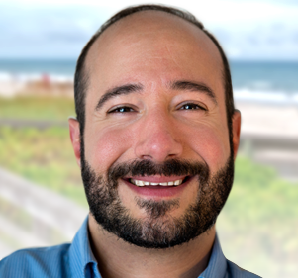
“Vinnie was born and raised in Brevard County and is the founder and CEO of Media‐Over‐Matter Productions, a multiple award-winning media production house. Nearly a million people and counting have seen his company’s projects worldwide. He ran the IT department for the Dean of Students Office at the University of Florida for ten years, received national grants focusing on computer usability and created a TV show based on computers and technology called “Campus Tech TV”.
A graduate of Leadership Brevard, he is a past recipient of LEAD Brevard’s 4 Under 40 and serves on the board of LEAD Brevard.”

